# **MPower Health: PDF Invoice Processing System**

**Approach 1:**

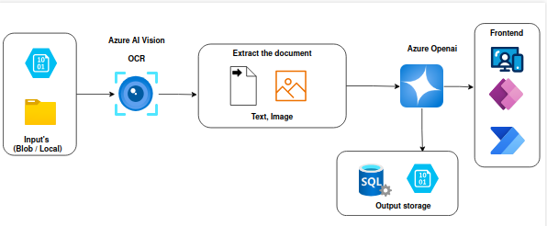

This architecture represents an end-to-end, automated document processing and analysis pipeline leveraging Azure and OpenAI services. Let’s walk through the workflow at a high level:

1. **Data Ingestion:**  
   Documents are sourced from either Azure Blob Storage or local directories, ensuring flexible input options for various business needs.
2. **Intelligent Document Processing:**Azure AI Vision performs advanced Optical Character Recognition (OCR) to extract both textual and visual elements from the documents. This step digitizes and structures unstructured content, enabling downstream analysis.
3. **Content Extraction:**  
   The system isolates and organizes key document components. such as text and images for targeted processing and interpretation.
4. **AI-Powered Analysis:**The extracted data is passed to Azure OpenAI, which leverages state-of-the-art language models to interpret, analyze, and generate insights from the document content. This could include summarization, classification, sentiment analysis, and more.
5. **Data Storage and Management:**Structured outputs are stored in a scalable SQL database, enabling efficient querying, reporting, and integration with downstream systems.
6. **User Interface and Automation:**  
   A modern frontend layer, powered by tools like Power Apps, and Power Automate, provides intuitive access to processed data and insights. This layer supports interactive custom applications, and automated workflows for streamlined operations.

**Approach 2:**

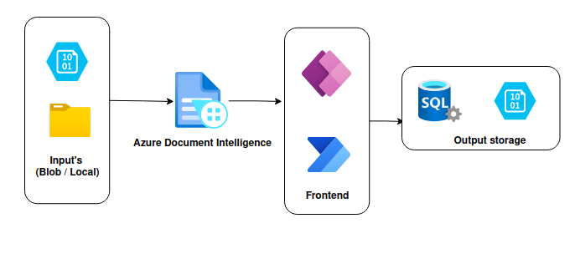

This diagram illustrates a streamlined document processing pipeline with Azure Document Intelligence, focusing on automated data extraction and integration. Let’s walk through the flow:

1. **Data Ingestion:**

Documents are sourced from Azure Blob Storage or local directories, providing flexible input channels for structured and unstructured data.

1. **Azure Document Intelligence:**

Azure Document Intelligence service processes the input documents, using AI-powered capabilities to extract key information such as structured data, tables, and text. This step enhances data accessibility and usability.

1. **Frontend Integration:**

The extracted information is made accessible through interactive frontend tools like Power Apps and Power Automate. These interfaces enable seamless user interaction, workflow automation, and real-time data management.

**Output Storage:**

Finally, the processed and structured data is stored in SQL databases or other Azure-based storage solutions, ensuring scalability, security, and efficient data retrieval.